Jarvis March

Jarvis march computes the CH(Q) by a technique known as gift wrapping or package wrapping.

Algorithm Jarvis March
- First, a base point p_{o} is selected, this is the point with the minimum y-coordinate.
  - Select leftmost point in case of tie.
- The next convex hull vertices p₁ has the least polar angle w.r.t. the positive horizontal ray from p_{o}.
  - Measure in counterclockwise direction.
  - If tie, choose the farthest such point.
- Vertices p₂, p₃, . . . , p_{k} are picked similarly until yk = ymax
  - p_{i+1} has least polar angle w.r.t. positive ray from p_{o}.
  - If tie, choose the farthest such point.

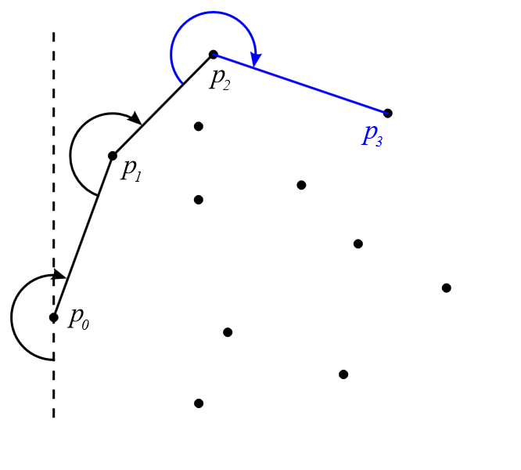

- The sequence p_{o}, p₁, . . . , p_{k} is right chain of CH(Q).
- To choose the left chain of CH(Q) start with p_{k}.
  - Choose pk+1 as the point with least polar angle w.r.t. the negative ray from p_{k}.
  - Again measure counterclockwise direction.
  - If tie occurs, choose the farthest such point.
  - Continue picking p_{k+1}, p_{k+2}, . . . , p_{t} in same fashion until obtain p_{t} = p_{o}.

Complexity of Jarvis March
For each vertex p belongs to CH(Q), it takes
- O(1) time to compare polar angles.
- O(n) time to find minimum polar angel.
- O(n) total time.
If CH(Q) has h vertices, then running time O(nh). If h = o(lg n) (this is little Oh), then this algorithm is asymptotically faster than the Graham’s scan. If points in set Q are generated by random generator, the we expect h = c lg n for c≈1.
In practice, Jarvis march is normally faster than Graham’s scan on most application. Worst case occurs when O(n) points lie on the convex hull i.e., all points lie on the circle.

