Fourier Transform

Definition of Fourier Transform
The Fourier transform is a representation of an image as a sum of complex exponentials of varying magnitudes, frequencies, and phases. The Fourier transform plays a critical role in a broad range of image processing applications, including enhancement, analysis, restoration, and compression.
If f(m,n) is a function of two discrete spatial variables m and n, then the two-dimensional Fourier transform of f(m,n) is defined by the relationship
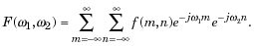
The variables ω₁ and ω₂ are frequency variables; their units are radians per sample. F(ω₁,ω₂) is often called the frequency-domain representation of f(m,n). F(ω₁,ω₂) is a complex-valued function that is periodic both in ω₁ and ω₂, with period . Because of the periodicity, usually only the range is displayed. Note that F(0,0) is the sum of all the values of f(m,n). For this reason, F(0,0) is often called the constant component or DC component of the Fourier transform. (DC stands for direct current; it is an electrical engineering term that refers to a constant-voltage power source, as opposed to a power source whose voltage varies sinusoidally.)
The inverse of a transform is an operation that when performed on a transformed image produces the original image. The inverse two-dimensional Fourier transform is given by
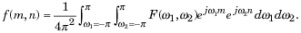
Roughly speaking, this equation means that f(m,n) can be represented as a sum of an infinite number of complex exponentials (sinusoids) with different frequencies. The magnitude and phase of the contribution at the frequencies (ω₁,ω₂) are given by F(ω₁,ω₂).

Visualizing the Fourier Transform
To illustrate, consider a function f(m,n) that equals 1 within a rectangular region and 0 everywhere else. To simplify the diagram, f(m,n) is shown as a continuous function, even though the variables m and n are discrete.
Rectangular Function
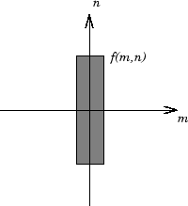
The following figure shows, as a mesh plot, the magnitude of the Fourier transform,
of the rectangular function shown in the preceding figure. The mesh plot of the magnitude is a common way to visualize the Fourier transform.
Magnitude Image of a Rectangular Function
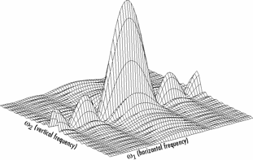
The peak at the center of the plot is F(0,0), which is the sum of all the values in f(m,n). The plot also shows that F(ω₁,ω₂) has more energy at high horizontal frequencies than at high vertical frequencies. This reflects the fact that horizontal cross sections of f(m,n) are narrow pulses, while vertical cross sections are broad pulses. Narrow pulses have more high-frequency content than broad pulses.
Another common way to visualize the Fourier transform is to display
as an image, as shown.
Log of the Fourier Transform of a Rectangular Function
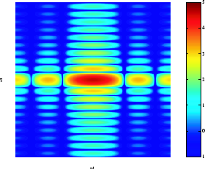
Using the logarithm helps to bring out details of the Fourier transform in regions where F(ω₁,ω₂) is very close to 0.
Examples of the Fourier transform for other simple shapes are shown below.
Fourier Transforms of Some Simple Shapes
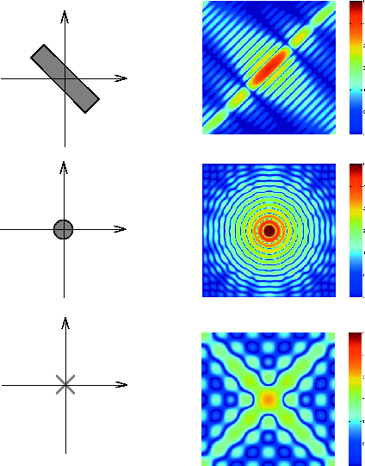
Back to Top

Discrete Fourier Transform
Working with the Fourier transform on a computer usually involves a form of the transform known as the discrete Fourier transform (DFT). A discrete transform is a transform whose input and output values are discrete samples, making it convenient for computer manipulation. There are two principal reasons for using this form of the transform:
- The input and output of the DFT are both discrete, which makes it convenient for computer manipulations.
- There is a fast algorithm for computing the DFT known as the fast Fourier transform (FFT).
The DFT is usually defined for a discrete function f(m,n) that is nonzero only over the finite region and . The two-dimensional M-by-N DFT and inverse M-by-N DFT relationships are given by
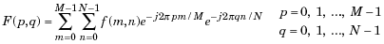
and
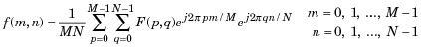
The values F(p,q) are the DFT coefficients of f(m,n). The zero-frequency coefficient, F(0,0), is often called the "DC component." DC is an electrical engineering term that stands for direct current. (Note that matrix indices in MATLAB always start at 1 rather than 0; therefore, the matrix elements f(1,1) and F(1,1) correspond to the mathematical quantities f(0,0) and F(0,0), respectively.)
The MATLAB functions fft, fft2, and fftn implement the fast Fourier transform algorithm for computing the one-dimensional DFT, two-dimensional DFT, and N-dimensional DFT, respectively. The functions ifft, ifft2, and ifftn compute the inverse DFT.

Relationship to the Fourier Transform
The DFT coefficients F(p,q) are samples of the Fourier transform F(ω₁,ω₂).
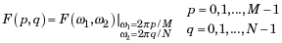

Visualizing the Discrete Fourier Transform
- Construct a matrix f that is similar to the function f(m,n) in the example in Definition of Fourier Transform. Remember that f(m,n) is equal to 1 within the rectangular region and 0 elsewhere. Use a binary image to represent f(m,n).
- f = zeros(30,30);
- f(5:24,13:17) = 1;
imshow(f,'InitialMagnification','fit')
- Compute and visualize the 30-by-30 DFT of f with these commands.
- F = fft2(f);
- F2 = log(abs(F));
- imshow(F2,[-1 5],'InitialMagnification','fit');
colormap(jet); colorbar
Discrete Fourier Transform Computed Without Padding
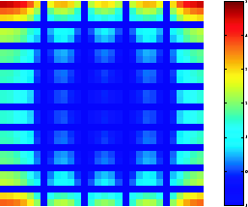
This plot differs from the Fourier transform displayed in Visualizing the Fourier Transform. First, the sampling of the Fourier transform is much coarser. Second, the zero-frequency coefficient is displayed in the upper left corner instead of the traditional location in the center.
- To obtain a finer sampling of the Fourier transform, add zero padding to f when computing its DFT. The zero padding and DFT computation can be performed in a single step with this command.
F = fft2(f,256,256);
This command zero-pads f to be 256-by-256 before computing the DFT.
imshow(log(abs(F)),[-1 5]); colormap(jet); colorbar
Discrete Fourier Transform Computed with Padding
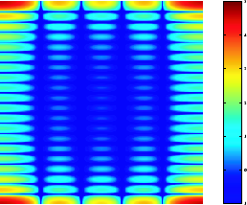
- The zero-frequency coefficient, however, is still displayed in the upper left corner rather than the center. You can fix this problem by using the function fftshift, which swaps the quadrants of F so that the zero-frequency coefficient is in the center.
- F = fft2(f,256,256);F2 = fftshift(F);
imshow(log(abs(F2)),[-1 5]); colormap(jet); colorbar
The resulting plot is identical to the one shown in Visualizing the Fourier Transform.
Back to Top

Applications of the Fourier Transform
This section presents a few of the many image processing-related applications of the Fourier transform.

Frequency Response of Linear Filters
The Fourier transform of the impulse response of a linear filter gives the frequency response of the filter. The function freqz2 computes and displays a filter's frequency response. The frequency response of the Gaussian convolution kernel shows that this filter passes low frequencies and attenuates high frequencies.
h = fspecial('gaussian');
freqz2(h)
Frequency Response of a Gaussian Filter
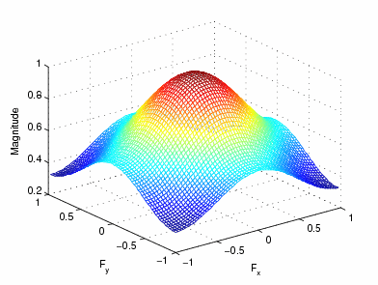
See Designing and Implementing 2-D Linear Filters for Image Data for more information about linear filtering, filter design, and frequency responses.

Fast Convolution
A key property of the Fourier transform is that the multiplication of two Fourier transforms corresponds to the convolution of the associated spatial functions. This property, together with the fast Fourier transform, forms the basis for a fast convolution algorithm.
Note The FFT-based convolution method is most often used for large inputs. For small inputs it is generally faster to use imfilter.
To illustrate, this example performs the convolution of A and B, where A is an M-by-N matrix and B is a P-by-Q matrix:
- Create two matrices.
- A = magic(3);
B = ones(3);
- Zero-pad A and B so that they are at least (M+P-1)-by-(N+Q-1). (Often A and B are zero-padded to a size that is a power of 2 because fft2 is fastest for these sizes.) The example pads the matrices to be 8-by-8.
- A(8,8) = 0;
B(8,8) = 0;
- Compute the two-dimensional DFT of A and B using fft2, multiply the two DFTs together, and compute the inverse two-dimensional DFT of the result using ifft2
C = ifft2(fft2(A).*fft2(B));
- Extract the nonzero portion of the result and remove the imaginary part caused by roundoff error.
- C = C(1:5,1:5);
C = real(C)
This example produces the following result.
C =

8.0000 9.0000 15.0000 7.0000 6.0000
11.0000 17.0000 30.0000 19.0000 13.0000
15.0000 30.0000 45.0000 30.0000 15.0000
7.0000 21.0000 30.0000 23.0000 9.0000
4.0000 13.0000 15.0000 11.0000 2.0000

Locating Image Features
The Fourier transform can also be used to perform correlation, which is closely related to convolution. Correlation can be used to locate features within an image; in this context correlation is often called template matching.
This example illustrates how to use correlation to locate occurrences of the letter "a" in an image containing text:
- Read in the sample image.
bw = imread('text.png');
- Create a template for matching by extracting the letter "a" from the image.
a = bw(32:45,88:98);
You can also create the template image by using the interactive version of imcrop.
The following figure shows both the original image and the template.
imshow(bw);
figure, imshow(a);
Image (left) and the Template to Correlate (right)
- Compute the correlation of the template image with the original image by rotating the template image by 180º and then using the FFT-based convolution technique described in Fast Convolution.
(Convolution is equivalent to correlation if you rotate the convolution kernel by 180º.) To match the template to the image, use the fft2 and ifft2 functions.
C = real(ifft2(fft2(bw) .* fft2(rot90(a,2),256,256)));
The following image shows the result of the correlation. Bright peaks in the image correspond to occurrences of the letter.
figure, imshow(C,[]) % Scale image to appropriate display range.
Correlated Image
- To view the locations of the template in the image, find the maximum pixel value and then define a threshold value that is less than this maximum. The locations of these peaks are indicated by the white spots in the thresholded correlation image. (To make the locations easier to see in this figure, the thresholded image has been dilated to enlarge the size of the points.)
- max(C(:))
- ans =
- 68.0000
- thresh = 60; % Use a threshold that's a little less than max.
figure, imshow(C > thresh) % Display pixels over threshold.
Correlated, Thresholded Image Showing Template Locations

